 **North Heights Chili & Game Night**

**Saturday, October 19, 2024**

**4:00 pm –**

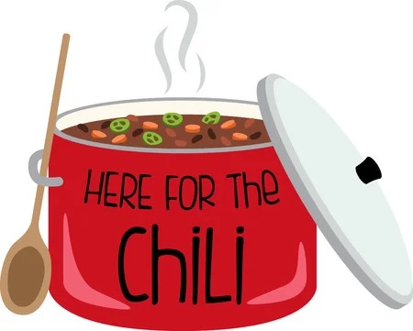

Attendance sign-up and sign up for chili fixin’ items and games on the bulletin board in the foyer.

Hope to see you there.

  